# Form MG 11

**WITNESS STATEMENT**

CJ Act 1967, s.9; MC Act 1980, ss.5A(3) (a) and 5B; Criminal Procedure Rules 2020, Rule 16.2, 19.4

|  |  |  |  |  |
| --- | --- | --- | --- | --- |
| URN |  |  |  |  |

|  |  |  |  |  |  |
| --- | --- | --- | --- | --- | --- |
| Statement of: | Firstname SURNAME B.Sc(Hons) | | | | |
| Age if under 18: | | Over 18 | (if over 18 insert ‘over 18’) | Occupation: | Digital Forensics Specialist |

This statement (consisting of XXX pages each signed by me) is true to the best of my knowledge and belief and I make it knowing that, if it is tendered in evidence, I shall be liable to prosecution if I have wilfully stated in it, anything which I know to be false, or do not believe to be true.

|  |  |  |  |  |
| --- | --- | --- | --- | --- |
| Signature: | **Type Your name** |  | Date: | XXX |

|  |  |  |
| --- | --- | --- |
| Tick if witness evidence is visually recorded |  | *(supply witness details on rear)* |

# Qualifications and Experience

1. I am employed as a Digital Forensics Specialist at The University of Greenwich’s Digital Forensic Consultation Service (DFCS). I have worked in the field of Digital Forensics since 2021. I have a Bachelor of Science degree in XXX from the University of Greenwich. I have undertaken specialist training in Digital Forensics as part of my degree from the University of Greenwich.
2. I have performed various examinations for both law enforcement and commercial organizations. I have previously given evidence in Court as an expert witness in relation to forensic computing cases.

# Background

1. This witness statement refers to actions I have undertaken during the examination of a forensic image supplied to me at the DFCS in the case referred to as Operation Canary Wharf.
2. I was not the person who imaged the original device, and for details relating to that please refer to the statement and notes of Mr. A. Aaron Adamson who is the imaging technician in this case. However, at the start of my examination, I performed a verification on the image that was supplied to me (called ‘Operation Canary Wharf’) and it was found to be correct.
3. I have received instructions from the Crown Prosecution Service and have been asked to conduct an examination of the image file in order to consider the following questions:

**Question 1:** The defendant has stated that he uses the laptop to play games online and do some university work, mostly doing his social activities on his phone. Are there artifacts present on the exhibit that support or undermine this assertion?

**Question 2:** Is there any evidence to show that the indecent photographs have been saved or accessed?

**Question 3:** If the laptop has been bought second-hand, is it possible that any discovered artifacts can be attributed to previous owners?

**Opinion:** Can you support the defendant’s statements about seeking to make composite pornographic pictures? We are particularly interested if there is anything on the device which indicates that the defendant, or anyone else, has made a conscious effort to search or access indecent material.

1. My examination was conducted using sound forensic methodology, tools and practices. I have followed the ‘Good Practice Guide for Digital Evidence’ produced by the Association of Chief Police Officers (ACPO).
2. During my examination I recorded my actions and observations in my original notes. These notes provide more detailed technical aspects of the forensic image of the exhibit and the processes and tools that I used. They can be produced if required.

# Summary of Findings

1. **With respect to question 1**, I found a **shadow gaming** web search on the web cache.

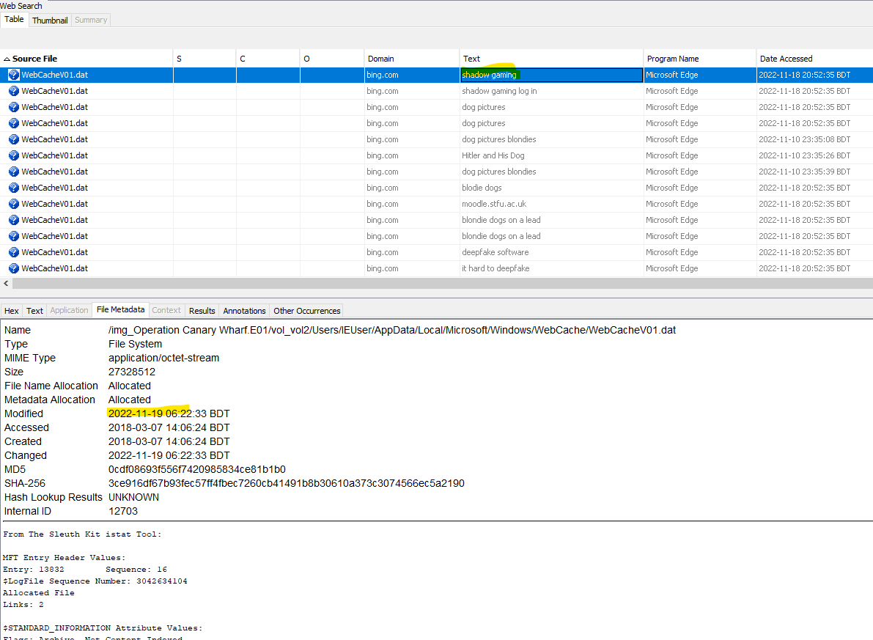

Here, I also found the research work on the topics **Deepfake of a BBC journal**.

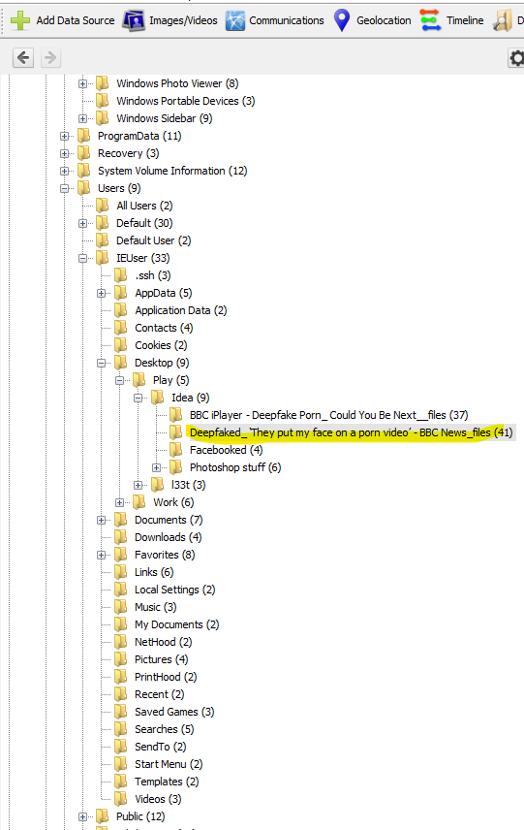

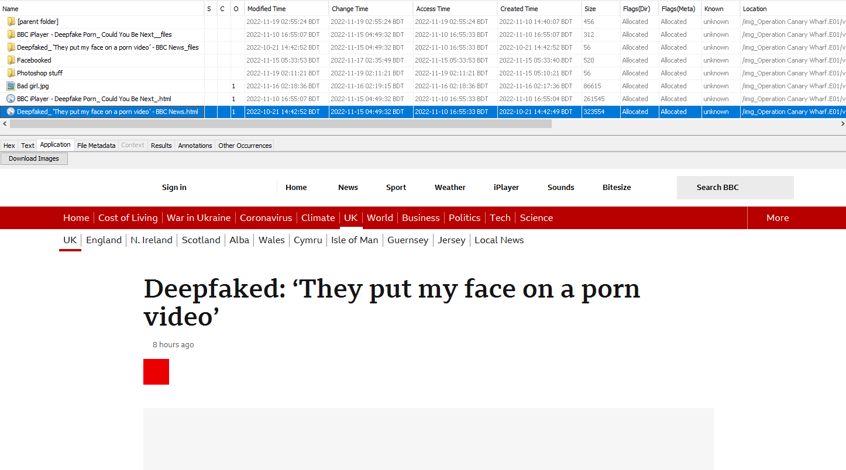

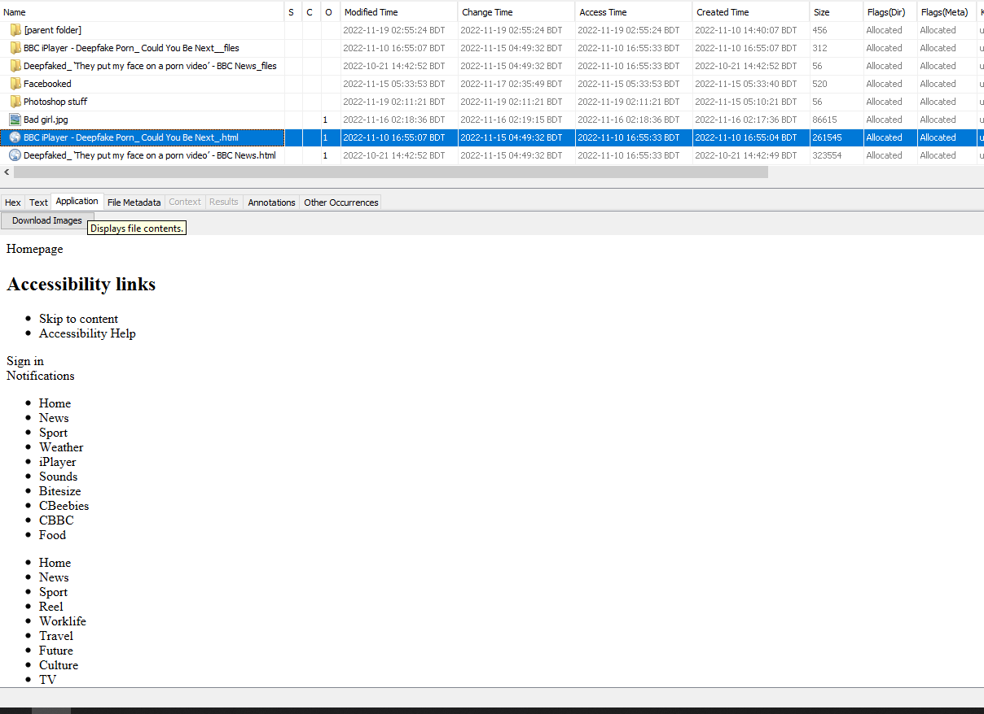

There also have some social activity and the platform was **Outlook.** Where defendant CHURCHILL

Send a mail **prof Trent.** But here the content of the mail was fishy.

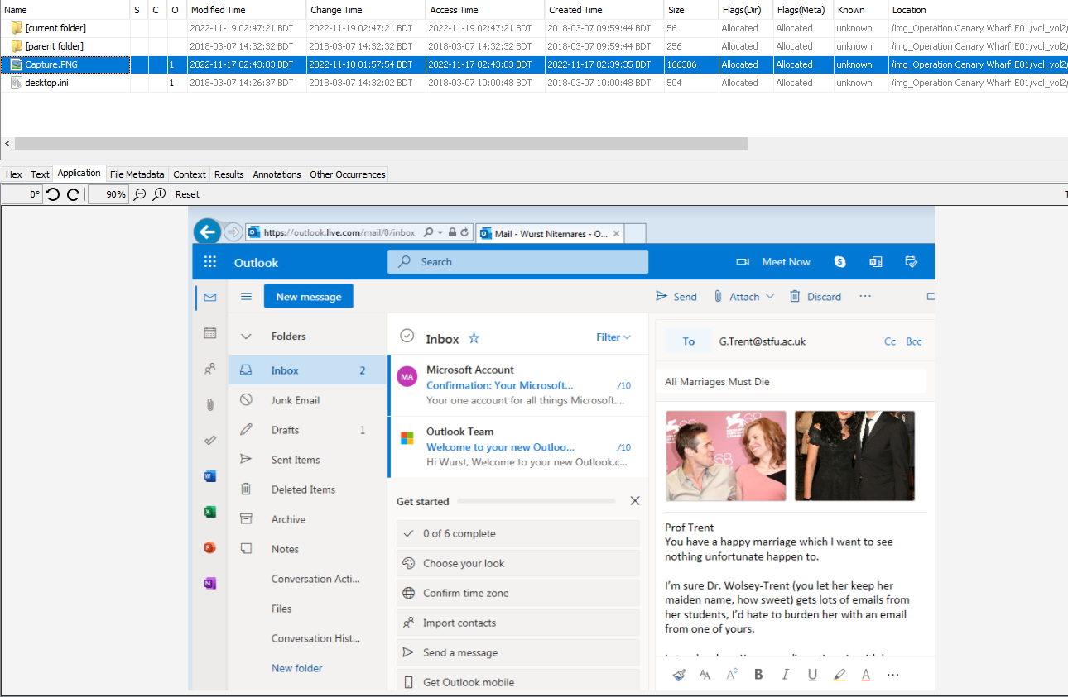

1. **With respect to question 2**, I found a lot of indecent photographs that have been saved or accessed. I found a lot of **child pornography** pictures that are saved on the defendant’s laptop. Some of them I show here.

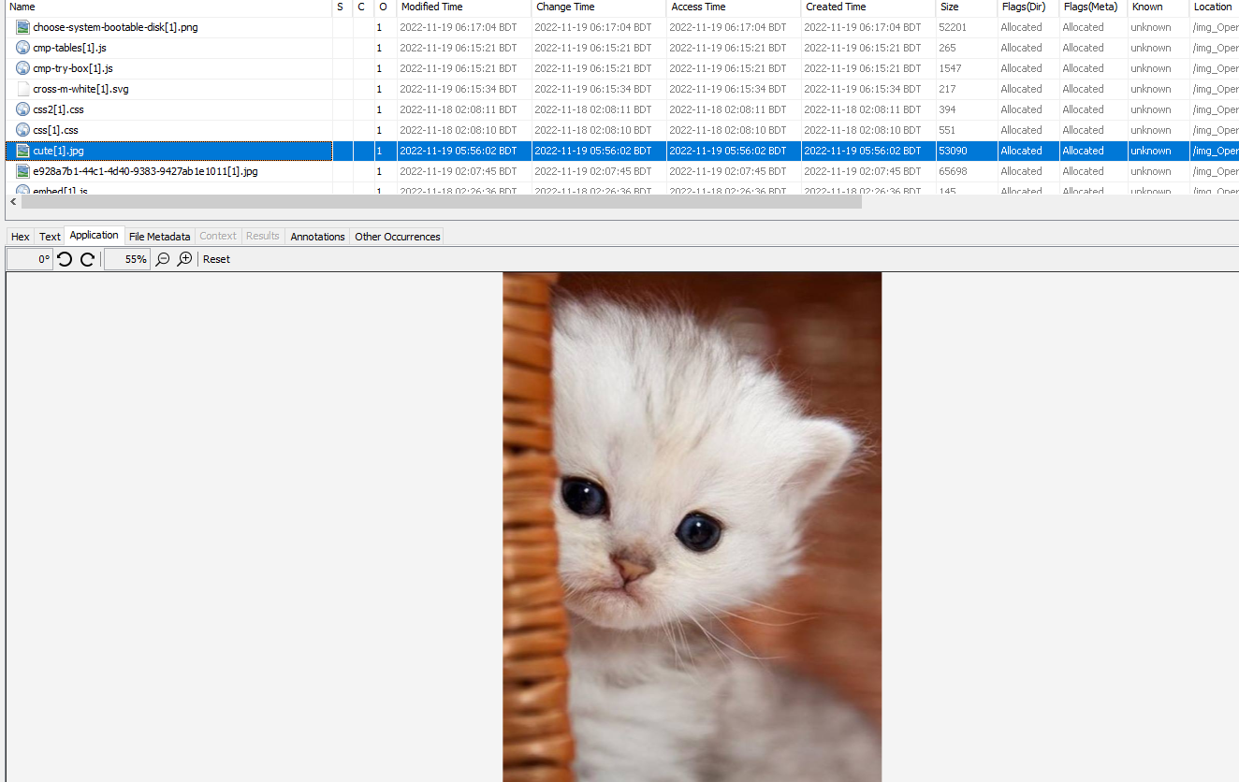

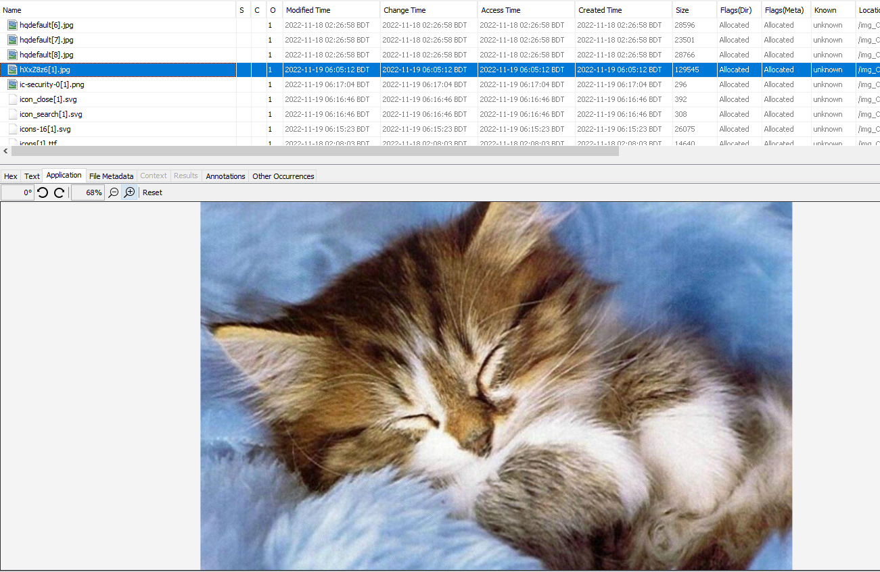

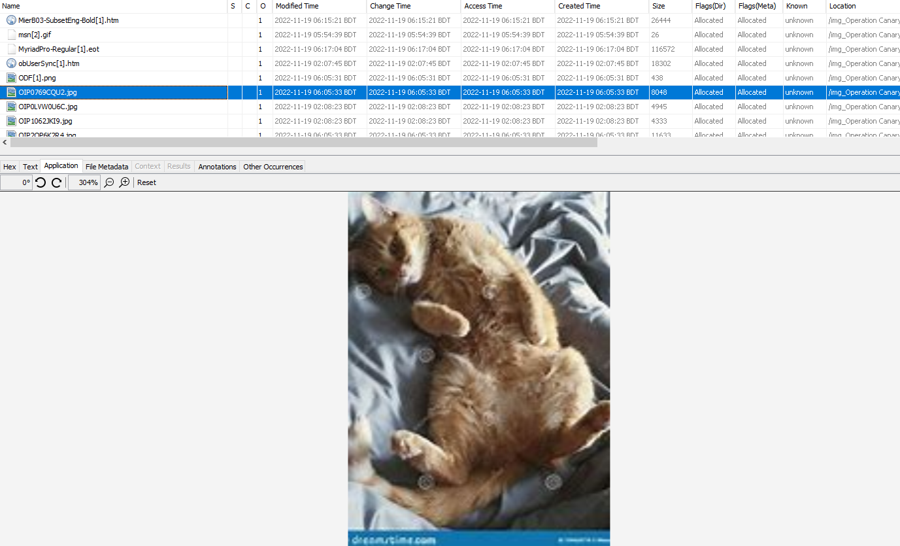

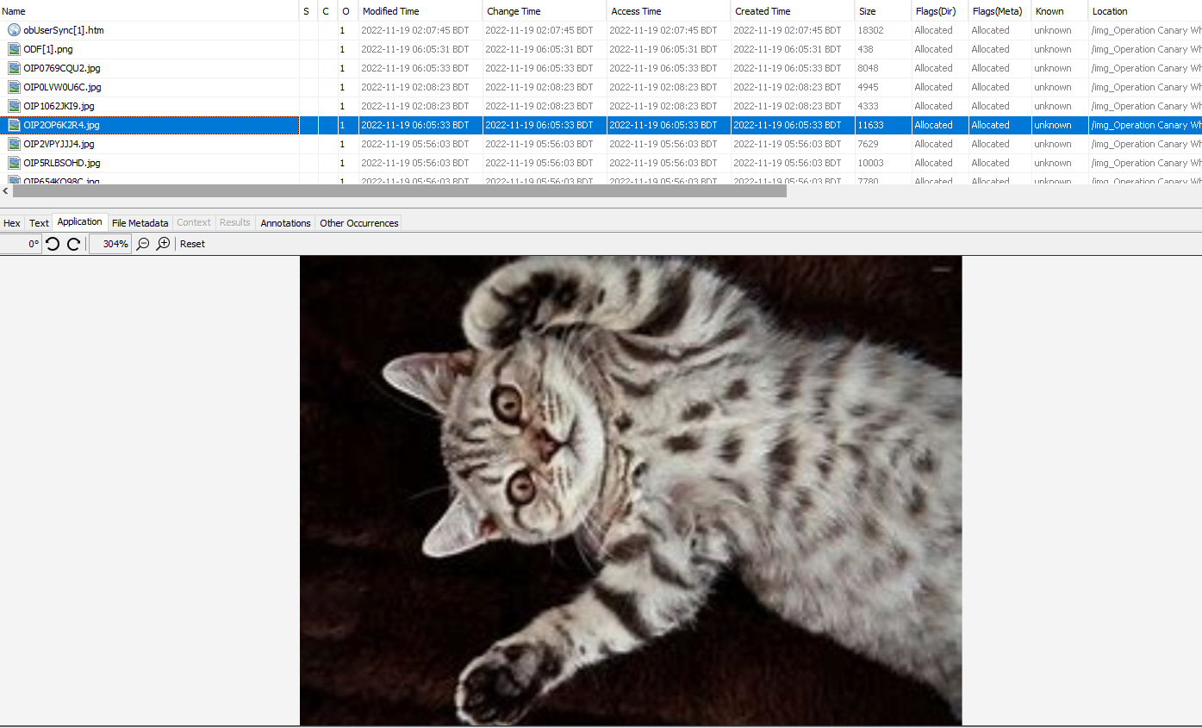

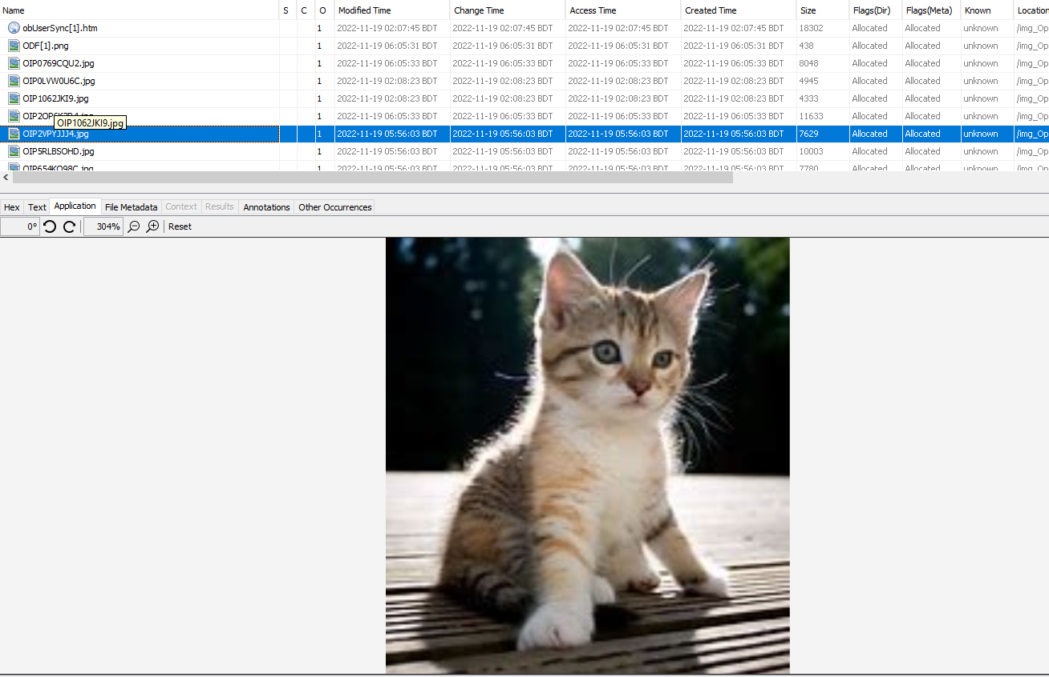

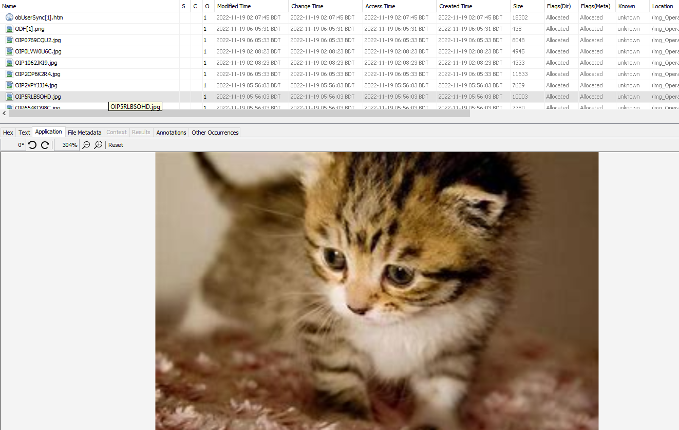

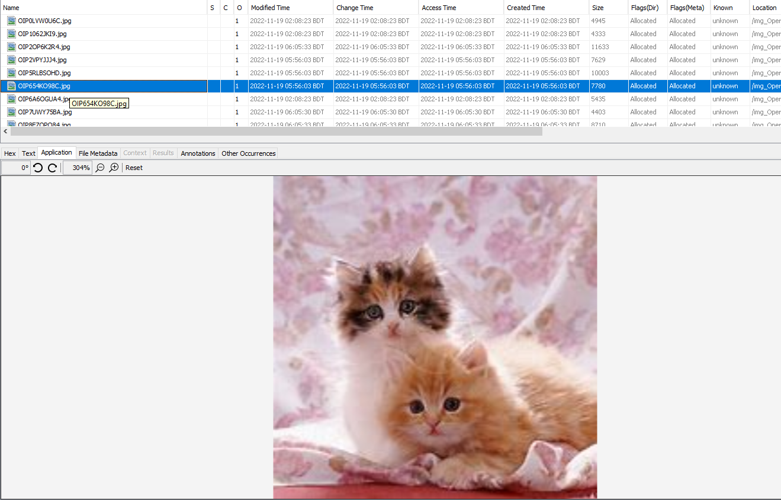

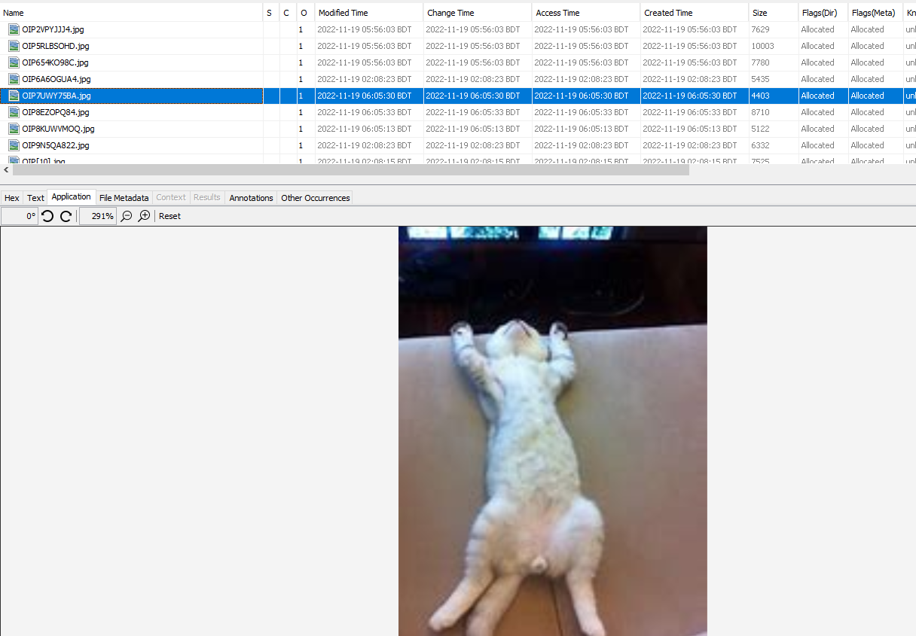

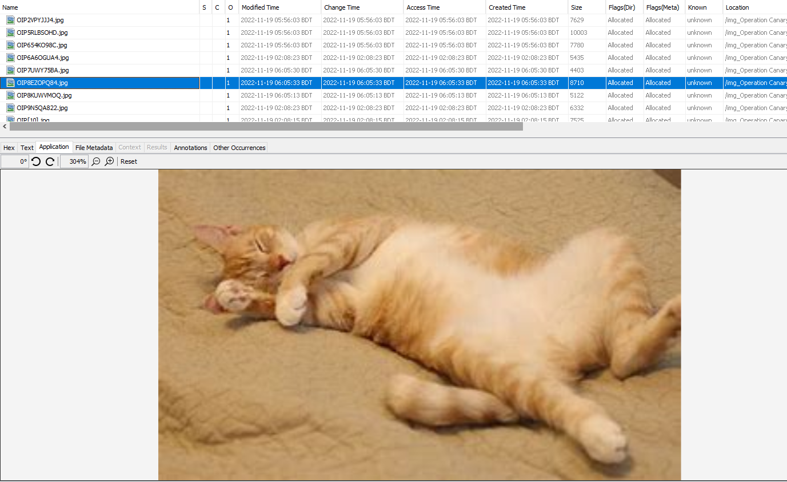

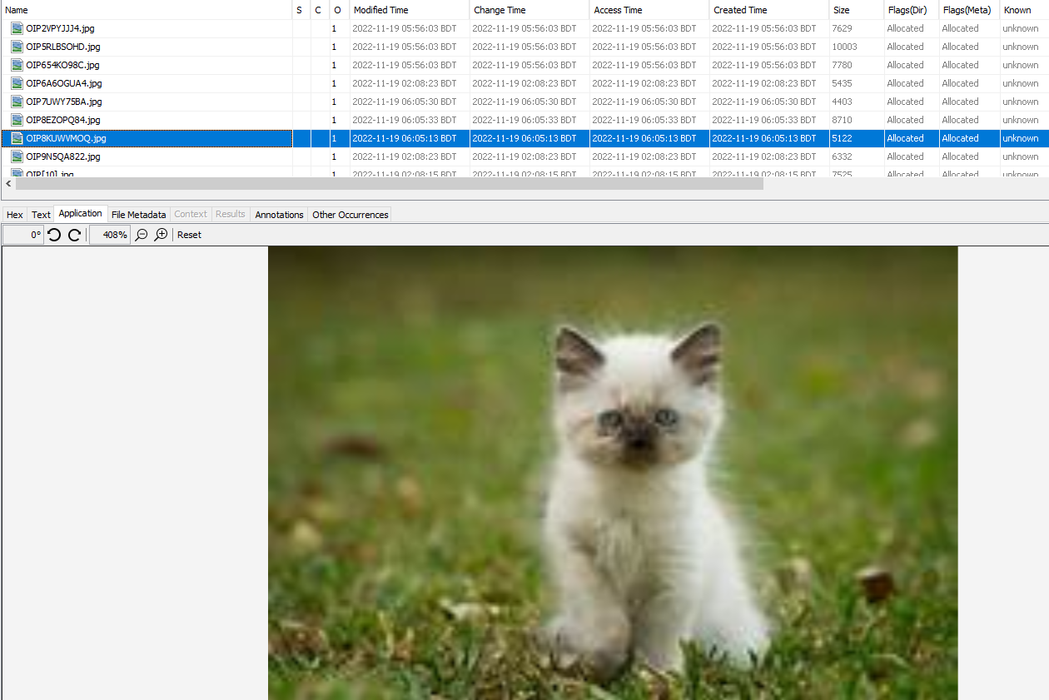

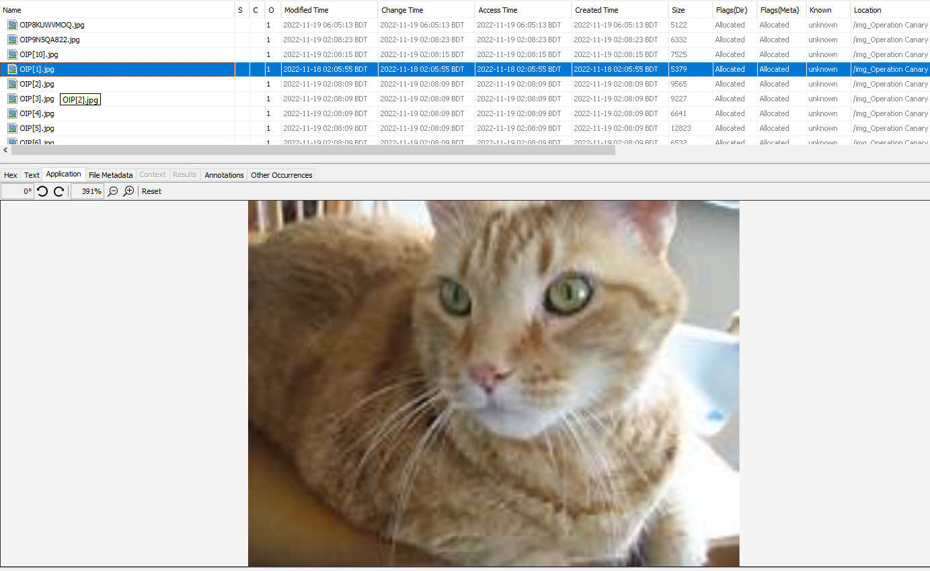

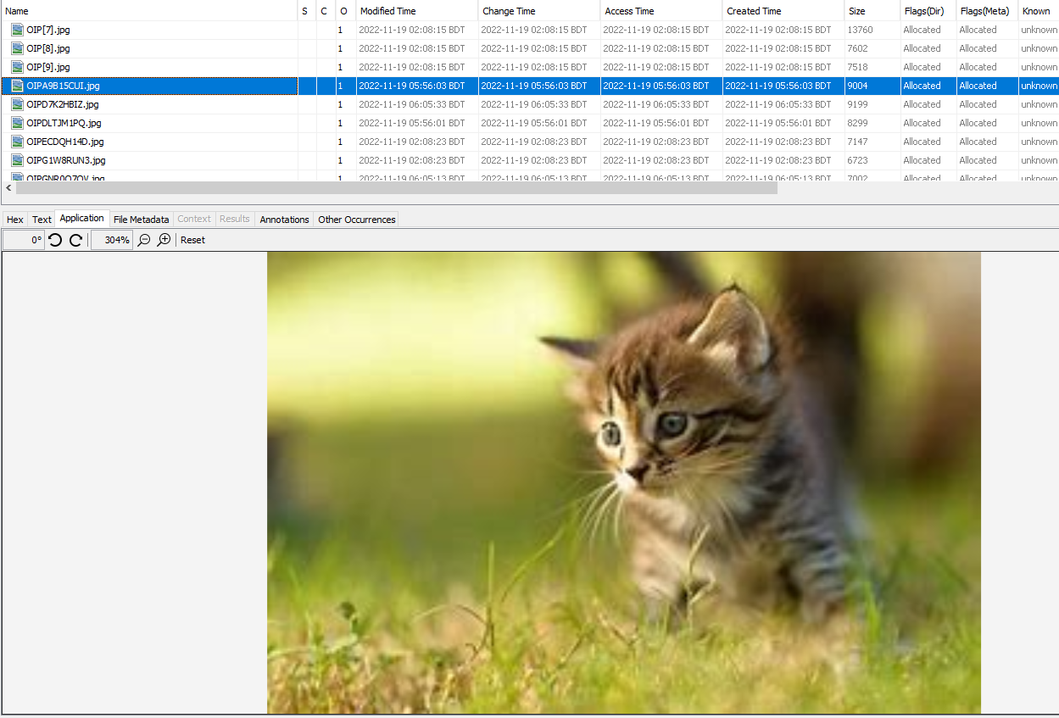

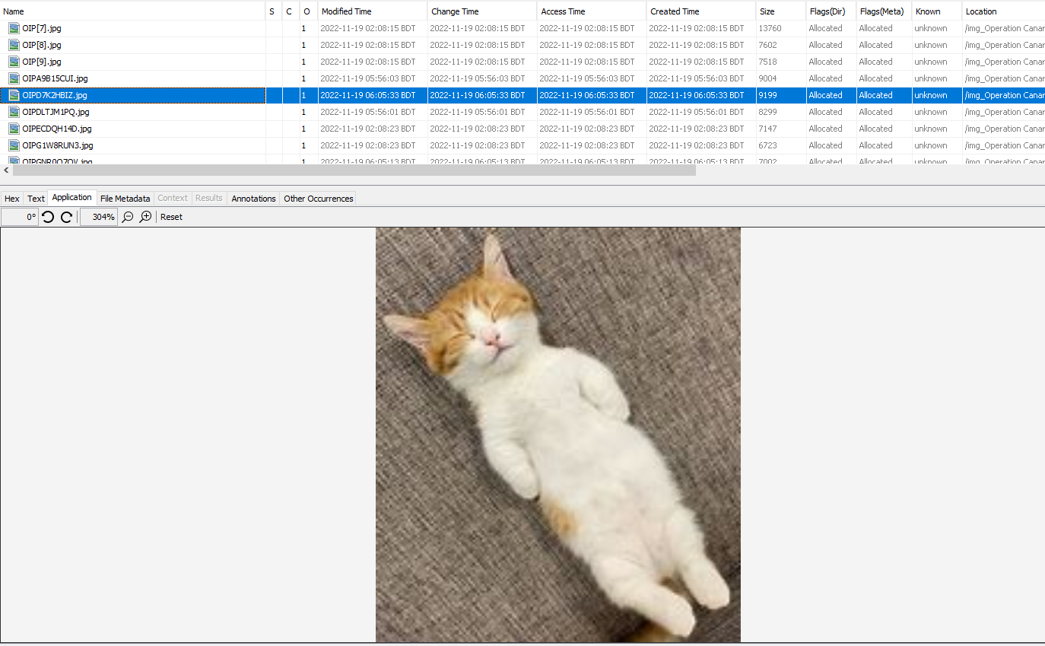

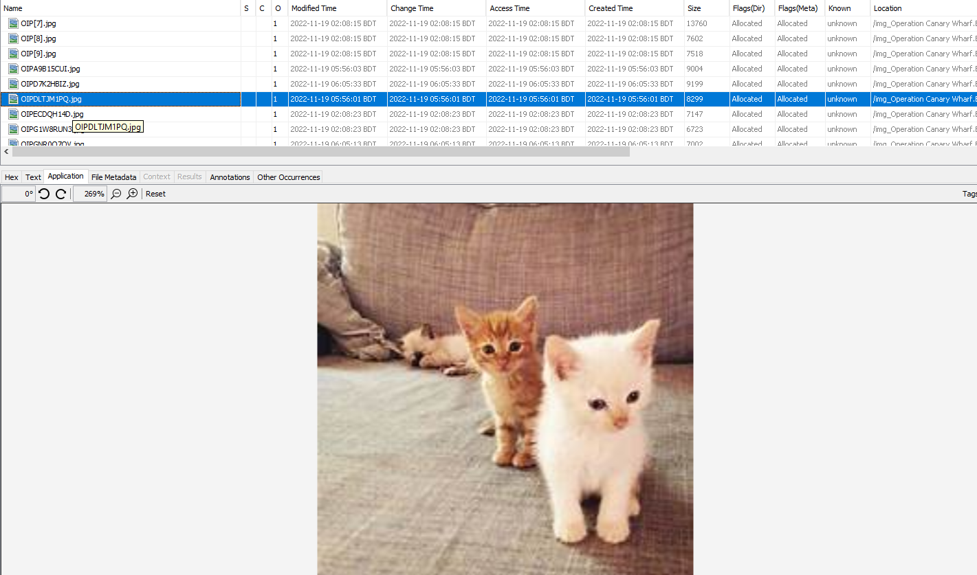

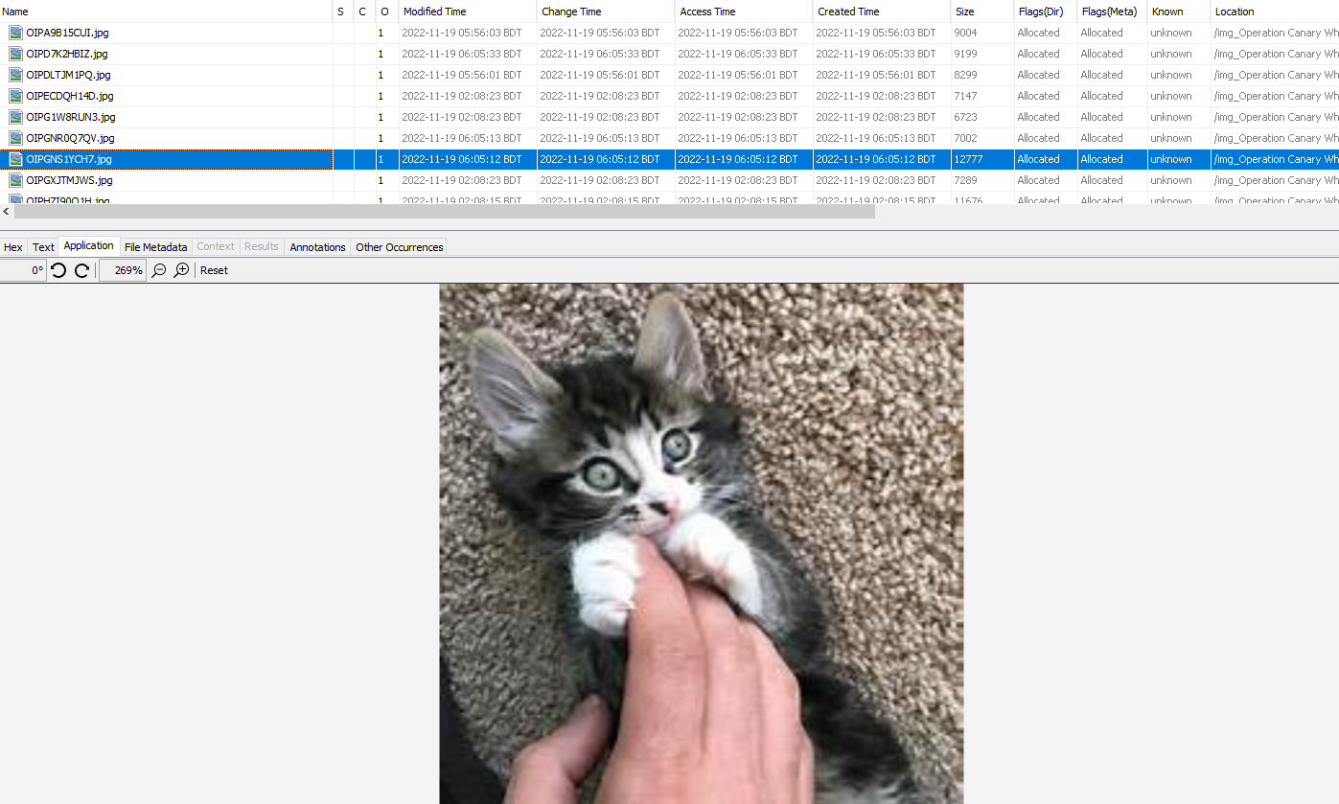

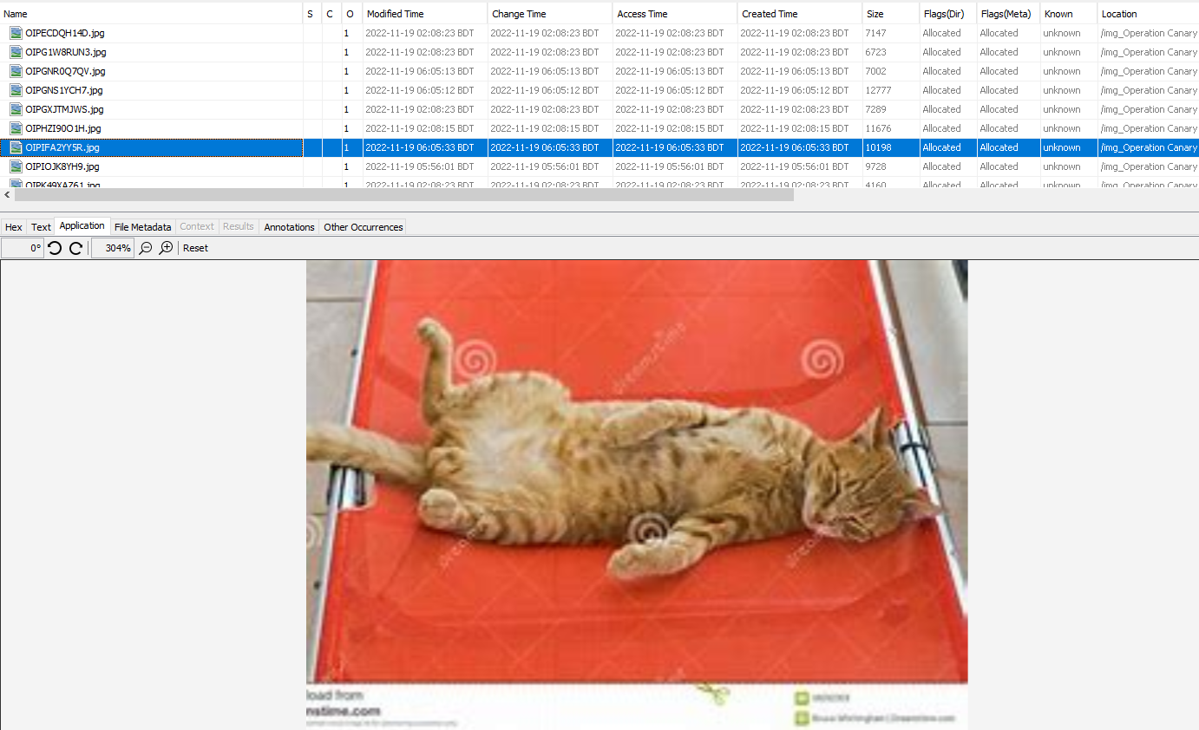

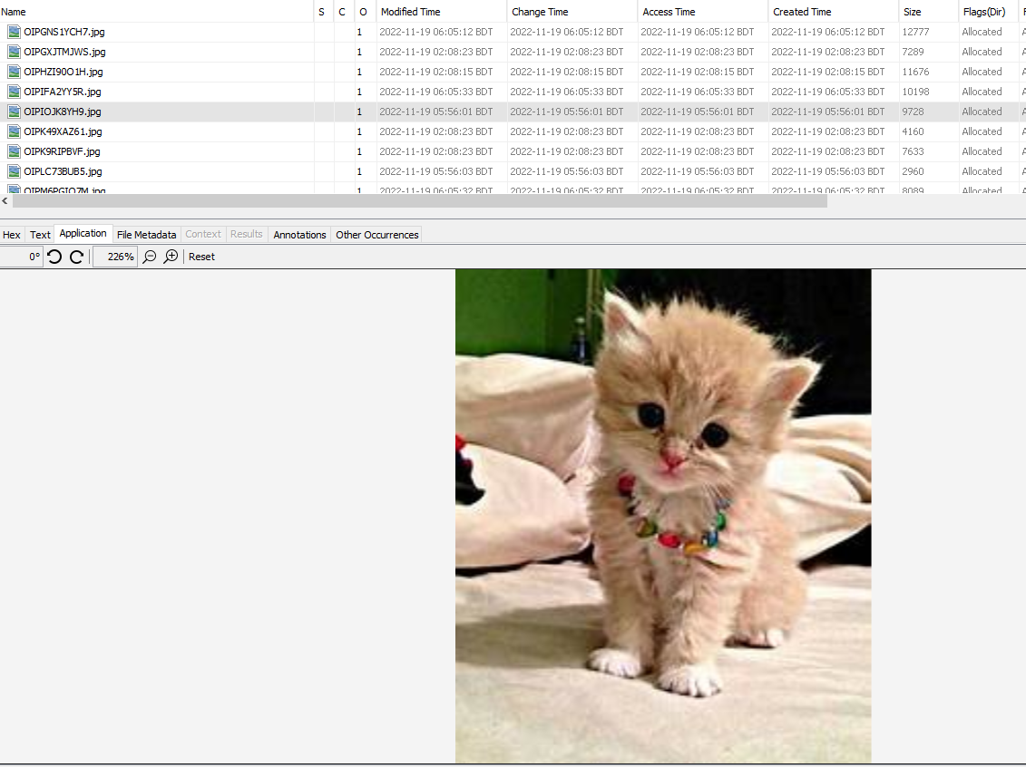

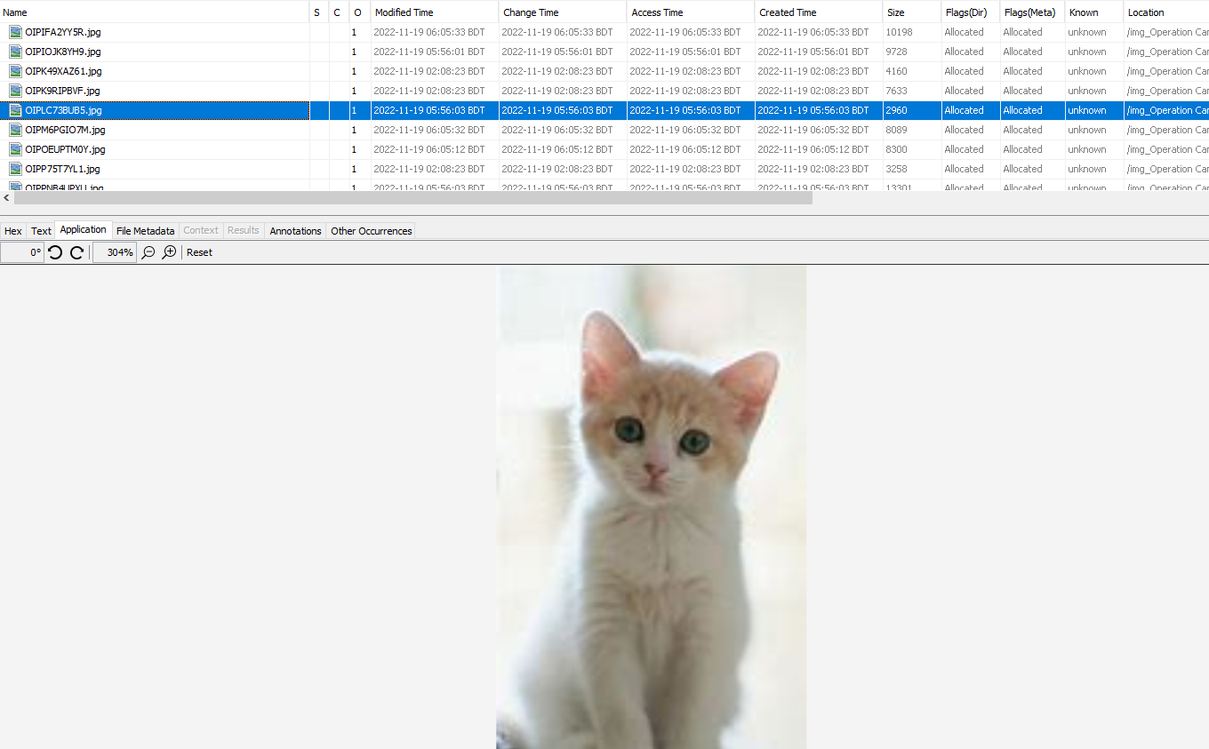

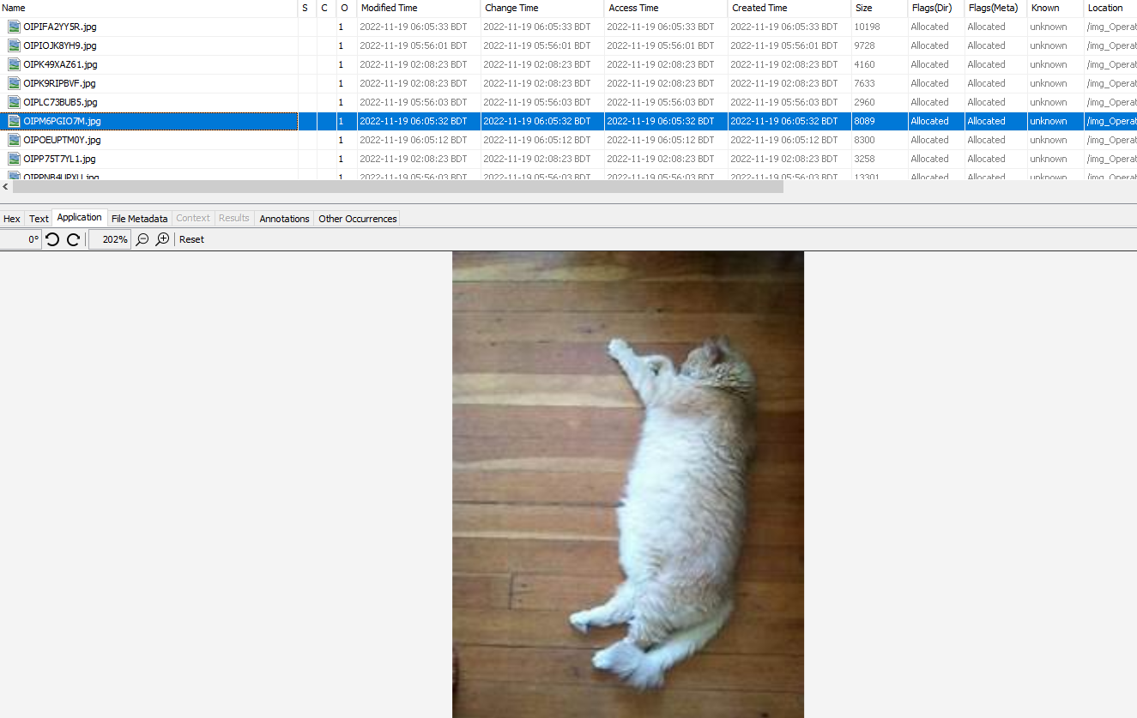

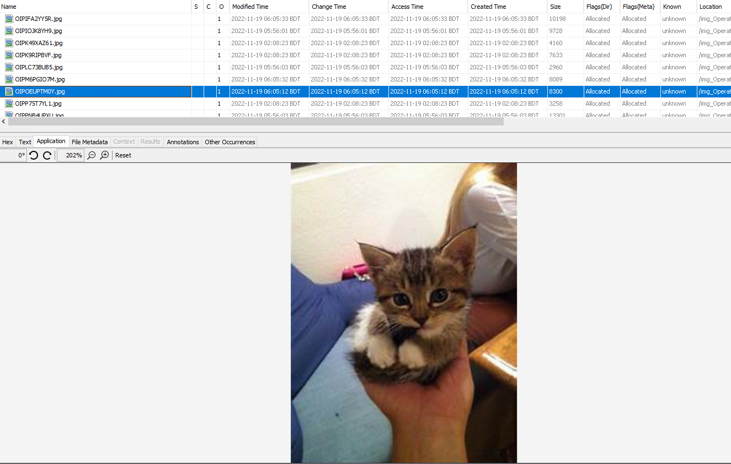

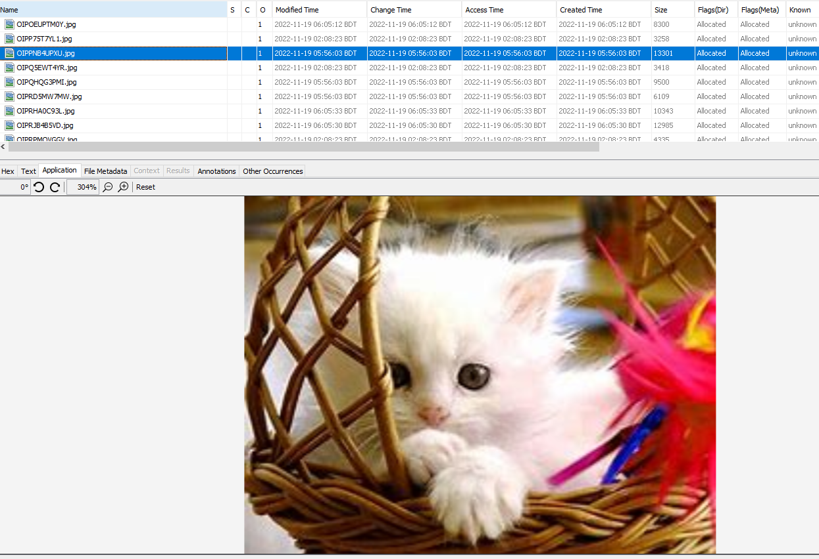

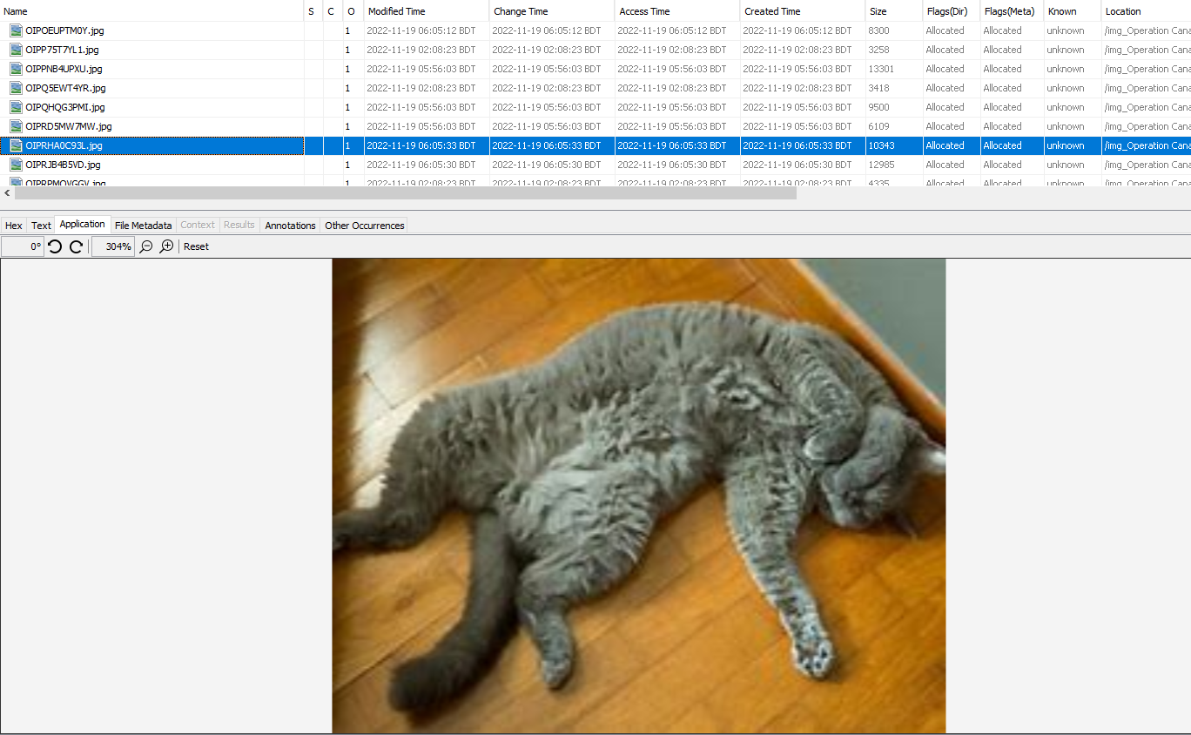

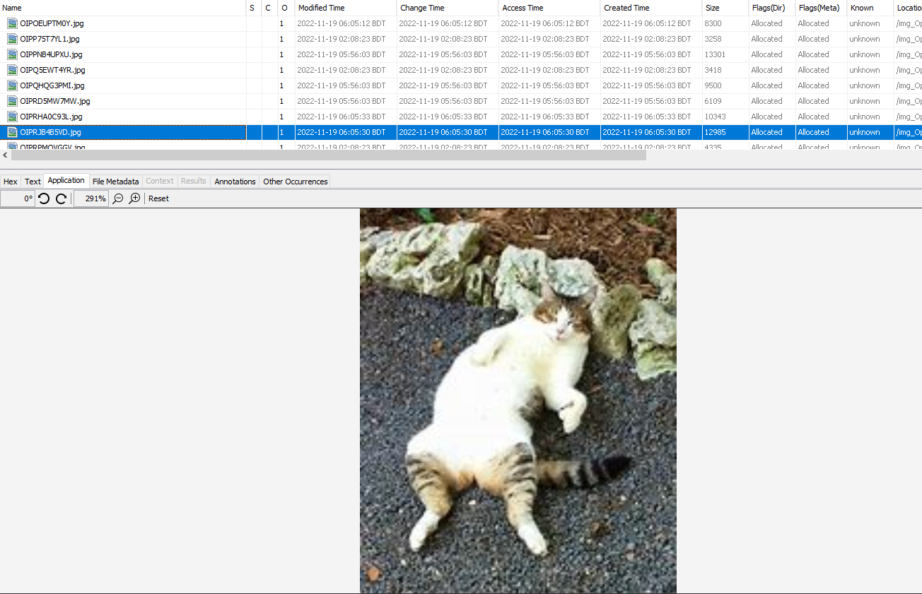

Here I mention the folder location where I find the photography of children’s pornography.

Path:

|  |  |
| --- | --- |
|  | /img_Operation Canary Wharf.E01/vol_vol2/Users/IEUser/AppData/Local/Microsoft/Windows/Temporary Internet Files/Content.IE5/3LEMN813/ |

And the metadata of this folder is-

|  |  |
| --- | --- |
| Name | /img_Operation Canary Wharf.E01/vol_vol2/Users/IEUser/AppData/Local/Microsoft/Windows/Temporary Internet Files/Content.IE5/3LEMN813 |
| Type | File System |
| MIME Type | null |
| Size | 208 |
| File Name Allocation | Allocated |
| Metadata Allocation | Allocated |
| Modified | **2022-11-19 06:17:04 BDT** |
| Accessed | **2022-11-19 06:17:04 BDT** |
| Created | **2022-11-18 02:05:55 BDT** |
| Changed | **2022-11-19 06:17:04 BDT** |
| MD5 | Not calculated |
| SHA-256 | Not calculated |
| Hash Lookup Results | UNKNOWN |
| Internal ID | 2091 |
|  |  |

In the web cache there I also found some web searches. Which directly indicates the **child’s pornography.**

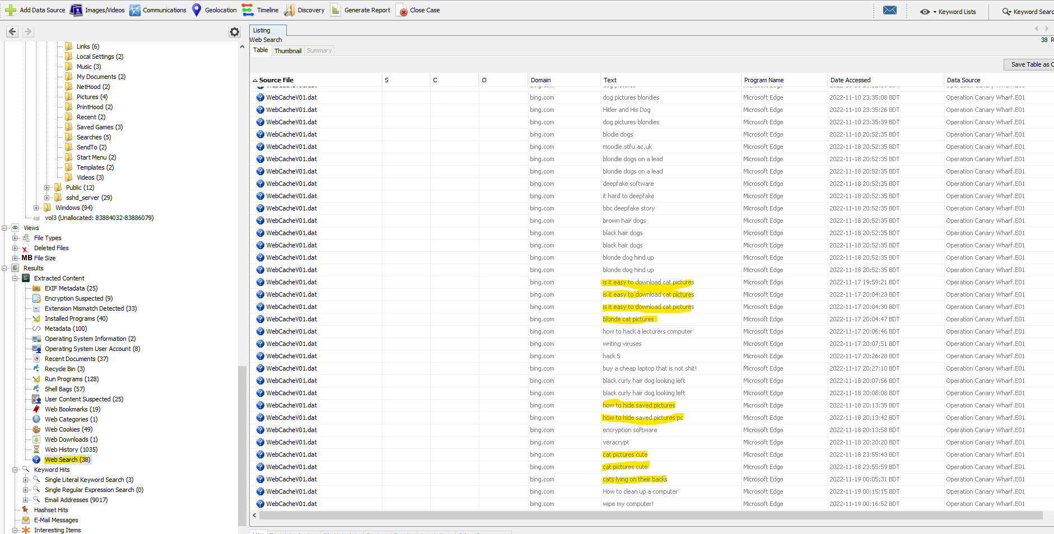

File metadata of web search:

|  |  |
| --- | --- |
| Name | /img_Operation Canary Wharf.E01/vol_vol2/Users/IEUser/AppData/Local/Microsoft/Windows/WebCache/WebCacheV01.dat |
| Type | File System |
| MIME Type | application/octet-stream |
| Size | 27328512 |
| File Name Allocation | Allocated |
| Metadata Allocation | Allocated |
| Modified | **2022-11-19 06:22:33 BDT** |
| Accessed | **2018-03-07 14:06:24 BDT** |
| Created | **2018-03-07 14:06:24 BDT** |
| Changed | **2022-11-19 06:22:33 BDT** |
| MD5 | 0cdf08693f556f7420985834ce81b1b0 |
| SHA-256 | 3ce916df67b93fec57ff4fbec7260cb41491b8b30610a373c3074566ec5a2190 |
| Hash Lookup Results | UNKNOWN |
| Internal ID | 12703 |

1. **With respect to question 3**, I found a file named overview.rtf. Their defendant mentioned that **“This new laptop is a piece of crap.”**

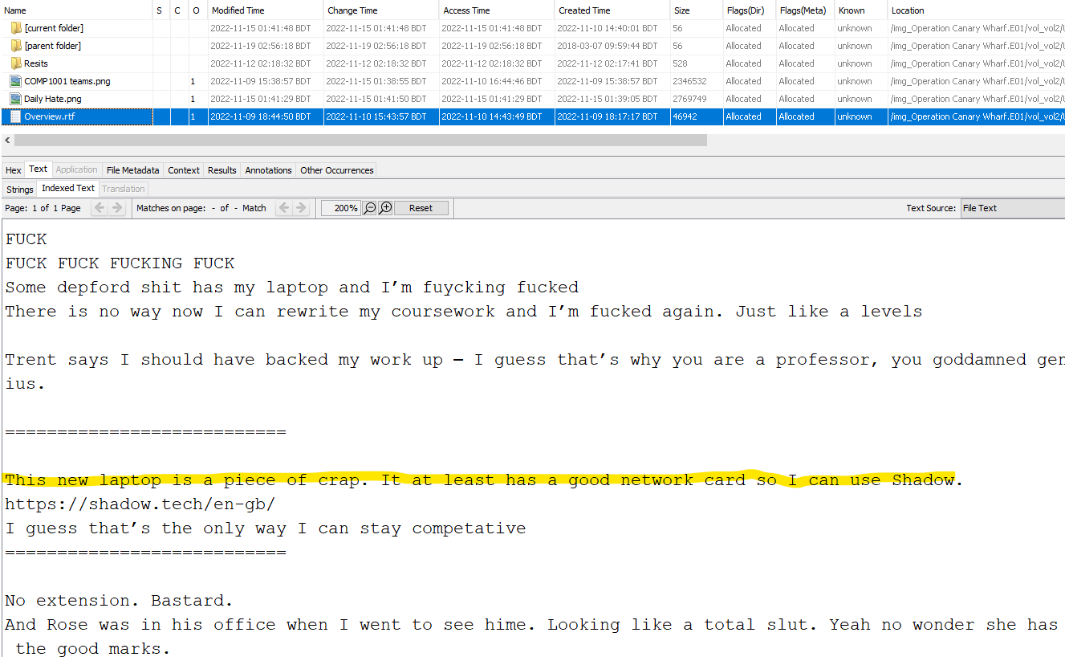

And the metadata of this file is-

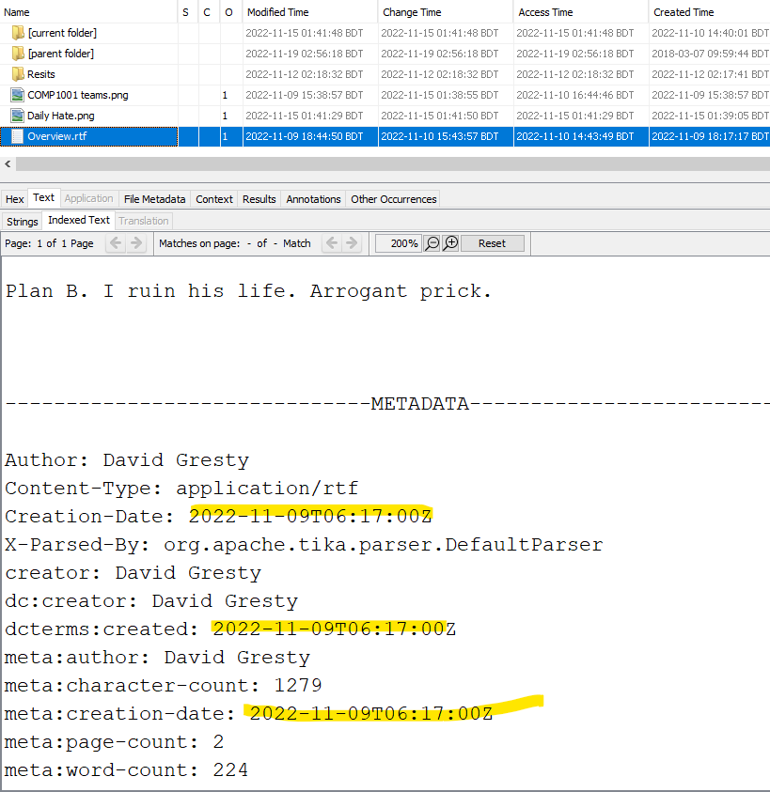

We can see here the file creation date was 2022-11-09. But the attempts defendant occurs after this time.

I also found a web search from the web cache where the defendant also searches for a **new laptop.**

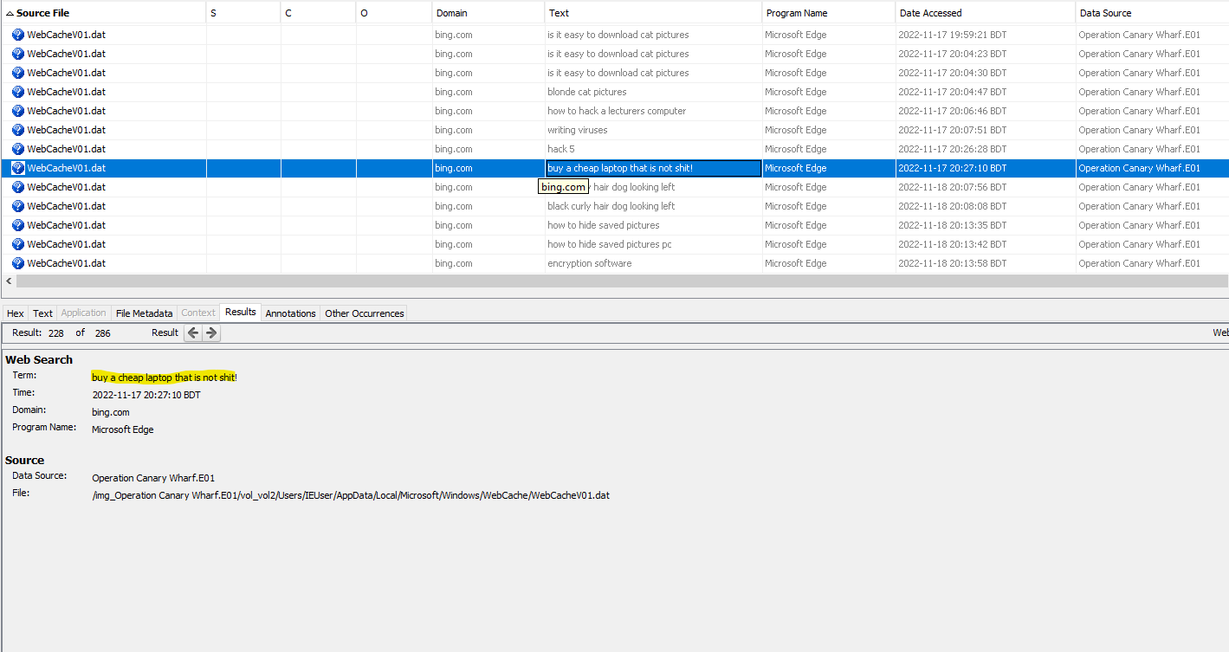

1. **In addition to the above I also found,** Some unethical activity of the defendant.

* On the defendant’s CHURCHILL statement, he state that wanted to make humorous meme-type pictures using classmates or lecturers at the university. But on the image file, I found many **deepfake porn** pictures of **Professor Giles Trent**.

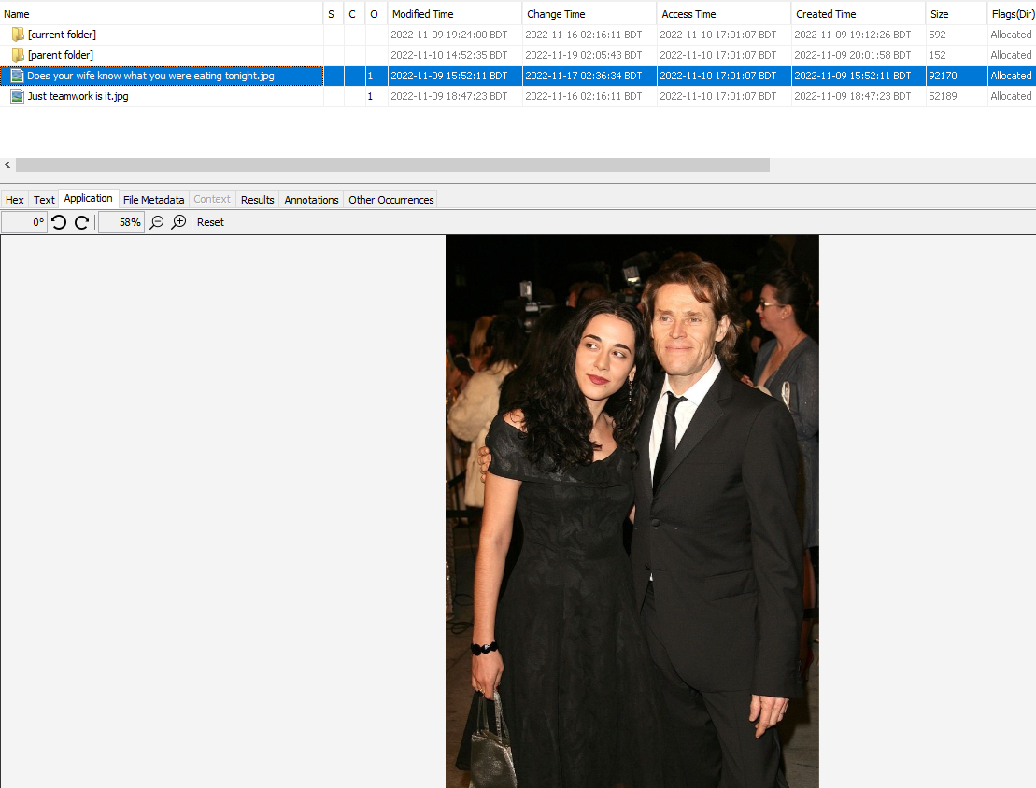

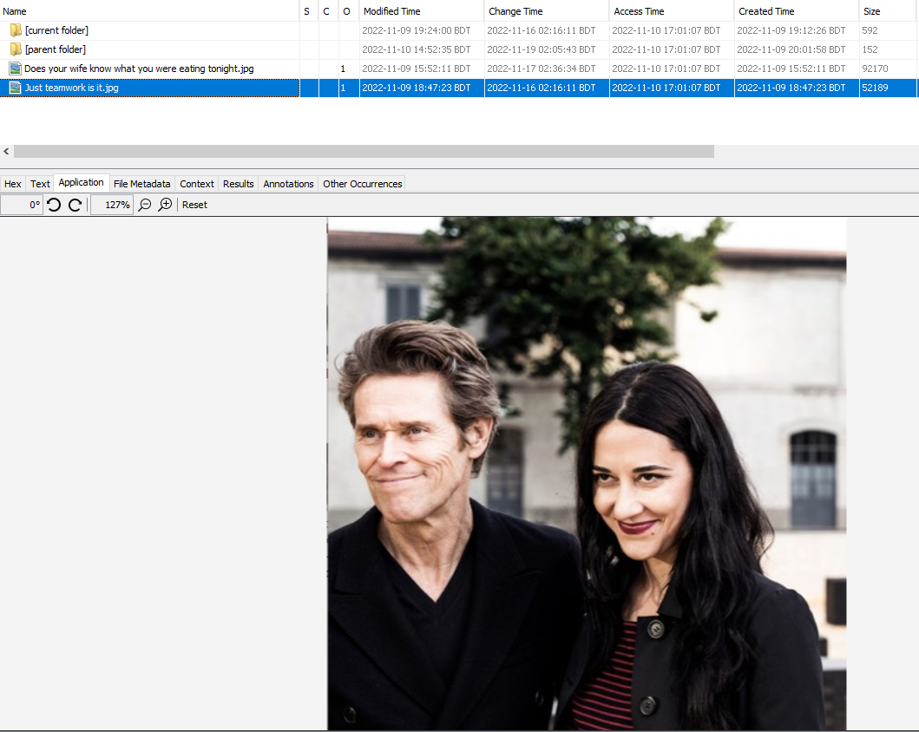

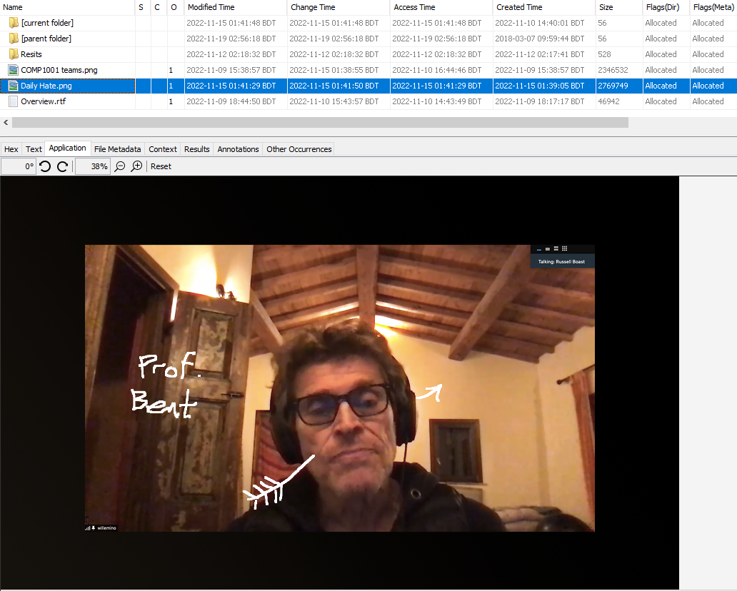

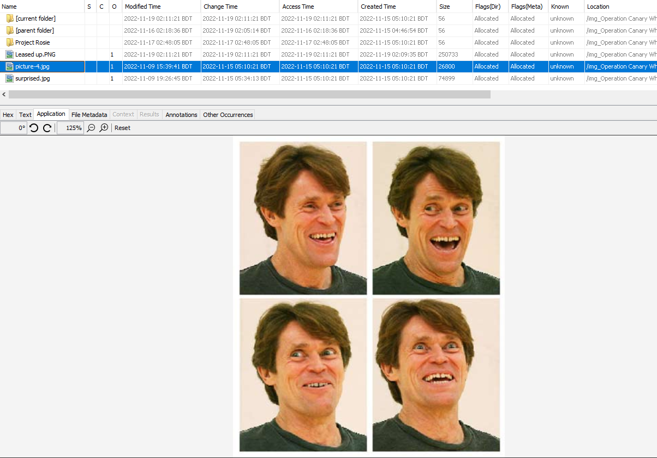

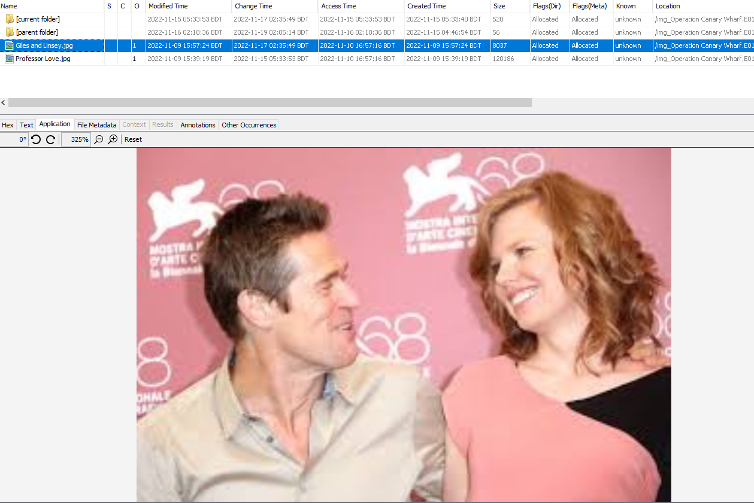

* The defendant also makes deepfake porn of his classmate **Rosie**. Which I found in the **Project Rosie folder**. And there I also found other’s **Deepfake porn**. Maybe it will be **Mrs. Giles Trent.**

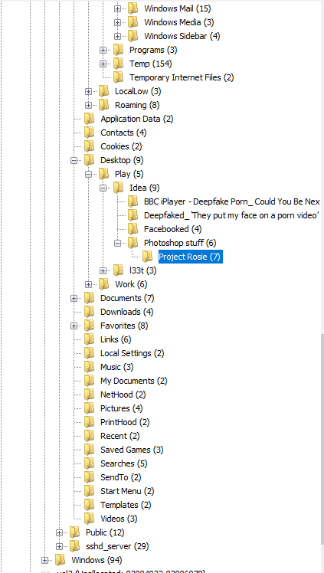

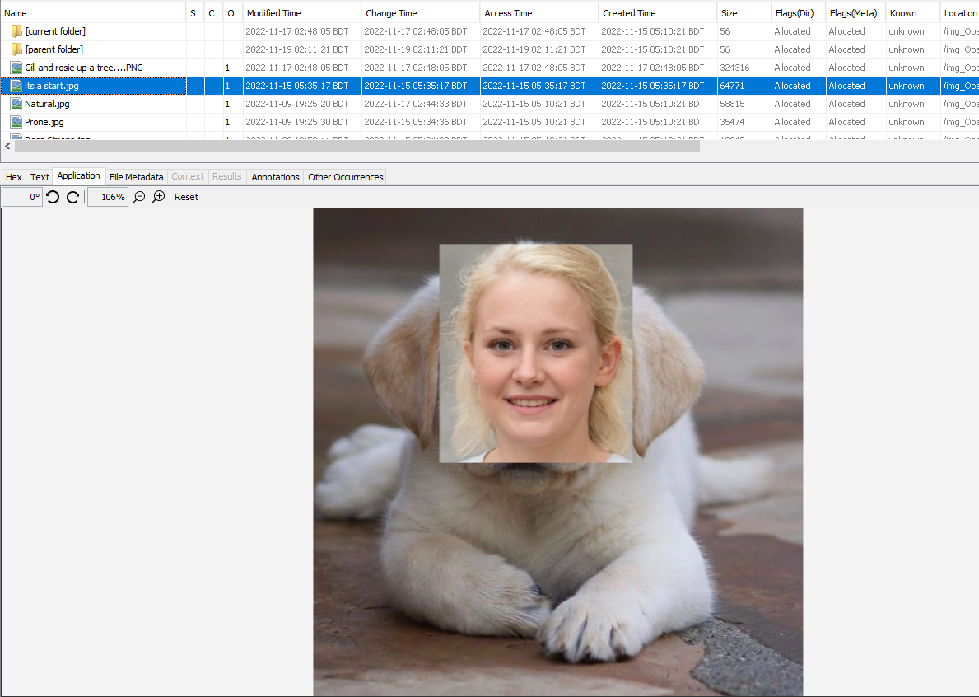

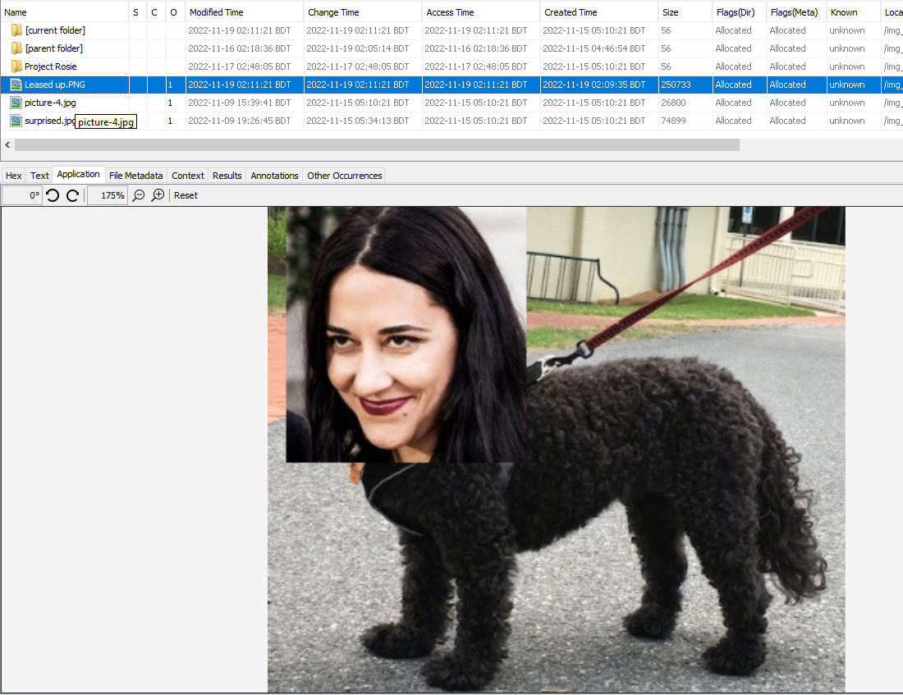

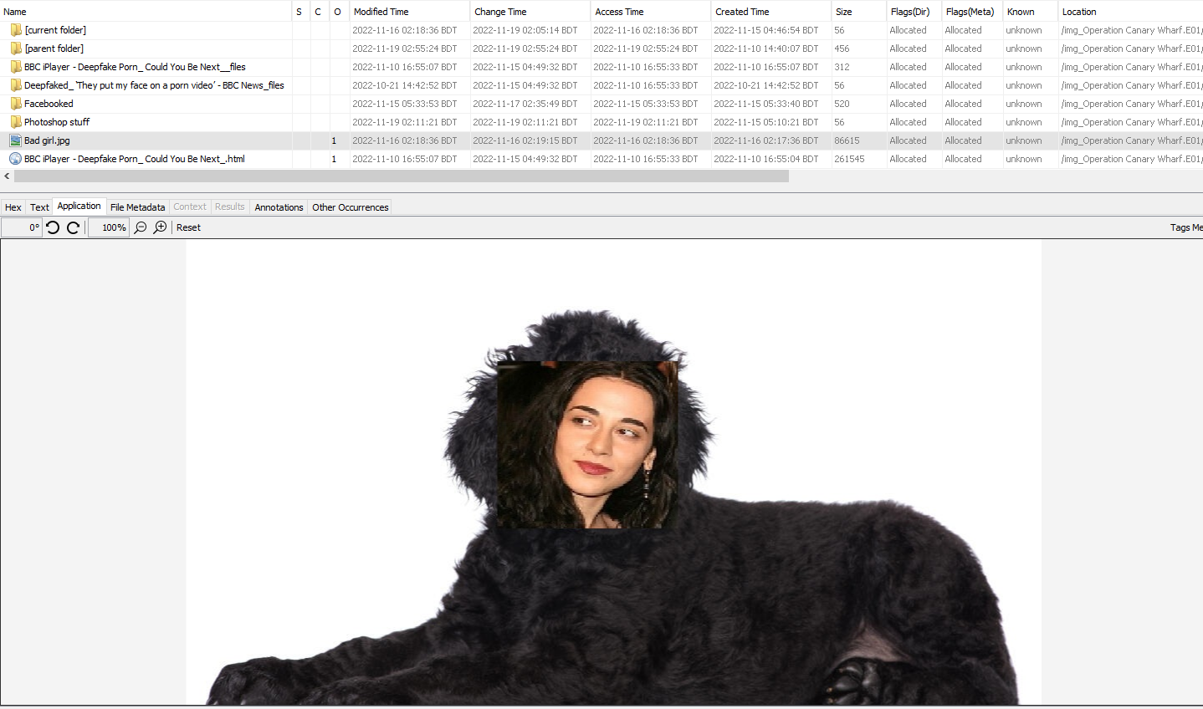

* I also found a file named ‘overview.rft’ which has some self-conversation bad comments from the defendant and where the defendant mentioned that he ruined Giles Trent’s life.

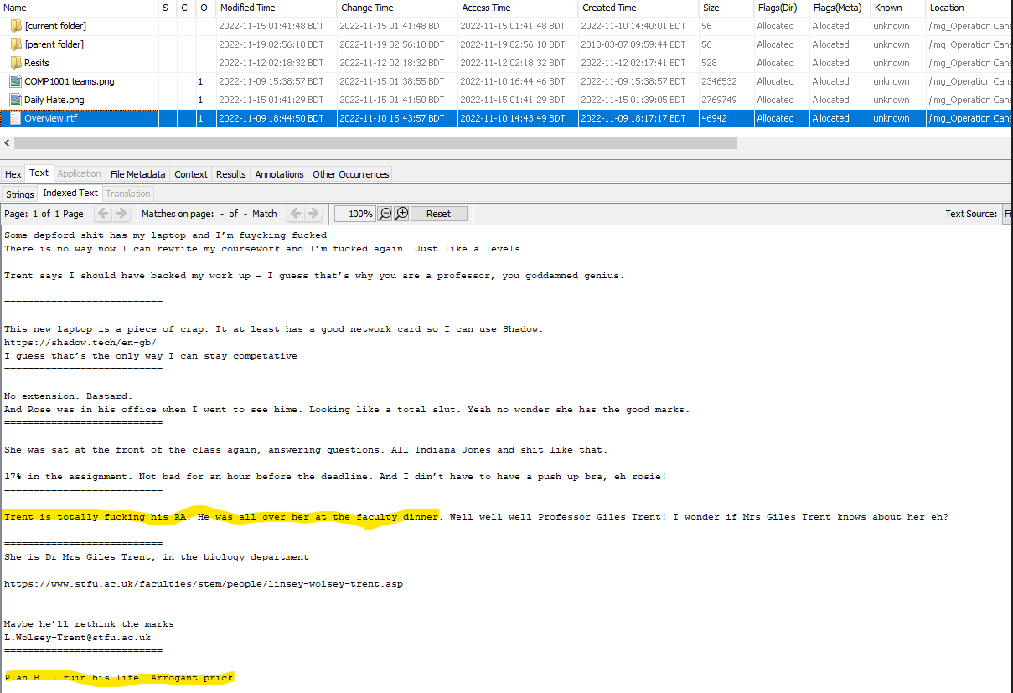

From the web cache, I also found some web search which is also fishy.

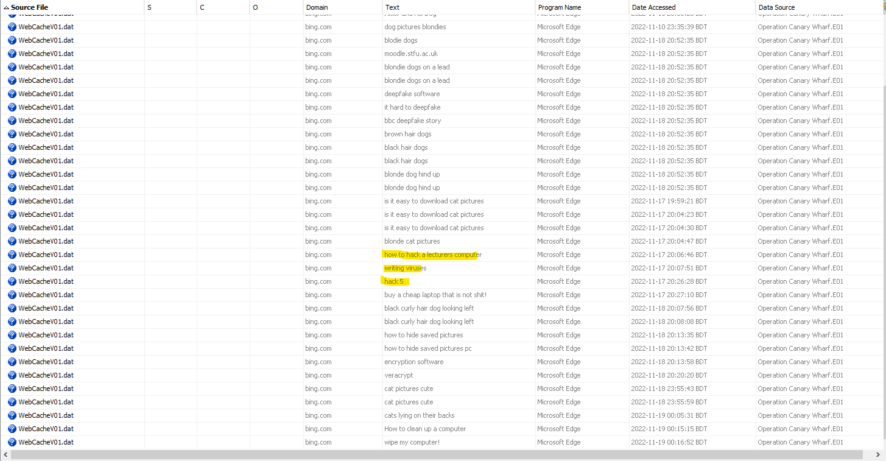

* There, I also found that the defendant sends a mail to **Professor Giles Trent**. Here we see that defendant tries to blackmail Professor.



# Detailed Findings for Exhibit ABC/1

1. The file ‘Operation Blue Canary Wharf’ is the forensic image of the exhibit, which is a laptop computer.
2. The currently installed operating system is Windows 7 Enterprise with a recorded installation/update date of 2018/03/07. There is a single Default user account present named IEUser which has no password set for it. My examination shows that the last recorded use of the computer was on Nov 19, 2022.

**Question 1:** The defendant has stated that he uses the laptop to play games online and do some university work, mostly doing his social activities on his phone. Are there artefacts present on the exhibit that support or undermine this assertion.

1. **Answer:** It is true that the defendant uses the laptop to play games and do some university work. Because In the web cashed I found some web searches about **shadow gaming**. I also found some research work about **deepfake** in **BBC journals**.

**Question 2:** Is there any evidence to show that the indecent photographs have been saved or accessed?

1. **Answer:** There have a lot of photographs of **child pornography** on the defendant’s laptop. And he saved these photographs in the folder of-

|  |  |
| --- | --- |
|  | **“/img_Operation Canary Wharf.E01/vol_vol2/Users/IEUser/AppData/Local/Microsoft/Windows/Temporary Internet Files/Content.IE5/3LEMN813/"** |

**Question 3:** If the laptop has been bought second-hand, is it possible that any discovered artifacts can be attributed to previous owners?

1. **Answer:** It is true that the laptop has been second-hand. Because the defendant searches for an old laptop on the web. And in the **‘overview.rtf’,** there he mentions that **“This new laptop is a piece of shit”**. But After analyzing the metadata of all findings, I assure that the discovered artifacts cannot be attributed to previous owners. Because all discovered artifactsacts are accessed or saved after the creation date of the **‘overview.rtf’** file. In this case, the creation and modification date of **‘overview.rft’** was **09-11-2022**. **The folder** where I discovered the image files and where the photography of **child pornography**, creation, and modification date was **19-11-2022.**

# Other Findings

1. The defendant is directly responsible for making the Deepfake porn photo. Where the victim was-

* **Professor Giles Trent**
* **And his classmate Rosie**

# Opinion

1. According to the all evidence, defendant CHURCHILL saved and access the photographs of children’s pornography. And he is also responsible for Deepfake porn where the victim was **Professor Giles Trent** And his **classmate Rosie**.

# Disclosure

1. I confirm that I have complied with my duties to record, retain and reveal material in accordance with the Criminal Procedure and Investigations Act 1996, as amended.
2. In the event my opinion changes on any material issue, I will inform the investigating officer as soon as reasonably practicable and give reasons.

# Duty to the Court

1. I declare that I understand that my duty, including providing written reports and giving evidence, is to assist the court and that this duty overrides any obligation to the party who has engaged me. I can confirm that I believe that I have complied with my duty.
2. I confirm that, to the best of my knowledge and belief, I have acted in accordance with the Code of Conduct published by the Forensic Science Regulator (Issue 4) in all aspects that relate to my personal conduct. Type Yourname at the very end to simulate signing after the last word

a squiggly line to the end of the page so no-one can add words to your statement